Integrating the Healthcare Enterprise



IHE PCC

Technical Framework Supplement

Labor and Delivery Record
(LDR)

Public Comment

Date: April 17, 2009
Author: Ana Estelrich
Email: ana_estelrich@yahoo.ca or ana.estelrich@sante.gouv

This is a supplement to the IHE PCC Technical Framework V4.0.

It is submitted for Public Comment between <June 15, 2009 and July 15, 2009>.

Comments shall be submitted within that period to http://forums.rsna.org:
- Select the “IHE” forum
- Select PCC Technical Framework
- Select 2009-2010 Supplements for Public Comment
- Select LDR
Please use the Public Comment Template provided there when starting your New Thread.

Details about IHE may be found at: www.ihe.net

Details about the IHE PCC may be found at: http://www.ihe.net/pcc/committees/index.cfm

Details about the structure of IHE Technical Frameworks and Supplements may be found at: http://www.ihe.net/About/process.cfm and http://www.ihe.net/profiles/index.cfm

The current version of the IHE PCC Technical Framework may be found at:. http://www.ihe.net/Technical_Framework/index.cfm

These ”boxed” instructions are for the author to indicate to the Volume Editor how to integrate the relevant section(s) into the overall Technical Framework
Replace Section X.X by the following:

TABLE OF CONTENTS

Introduction 3
Profile Abstract 3
Open Issues and Questions 5
Closed Issues 5
1.7 History of Annual Changes 10
2.1 Dependencies among Integration Profiles 10
2.2.X OB Labor/Delivery and Postpartum Record Integration Profile 11
X.1 Actors/ Transactions 11
X.2 Labor/Delivery and Postpartum Record Integration Profile Options 12
X.3 Labor/Delivery and Postpartum Record Process Flow 12
X.3 Grouping 15
X.3.1 Content Bindings with XDS, XDM and XDR 15
1.1.1 Cross Enterprise Document Sharing, Media Interchange and Reliable Messages 16
1.1.2 Notification of Document Availability (NAV) 16
1.1.3 Document Digital Signature (DSG) 16
X.4 OB-LDP Security Considerations 16
3.Y <Transaction Name> 18
3.Y.1 Scope 18
3.Y.2 Use Case Roles 18
3.Y.3 Referenced Standard 18
3.Y.4 Interaction Diagram 18

Introduction
The labor and delivery record (LDR) is a continuation of the Antepartum Record (APR). LDR offers all health care providers important information for the care for the mother and the newborn. The LDR provides comprehensive information regarding the course of labor and deilvery to providers caring for both the mother and the newborn in the postpartum period. For example, in cases such as chorioamnionitis or birth trauma, if the postpartum nurses or the attending obstetrician may not have been present at the birth, the LDR would be crucial for appropriate inpatient postpartum care. Also, the pediatrician might use the information present in the LDR to develop the infant’s plan of care in an outpatient setting. The outpatient care is out of the scope of this profile.

In some settings, public health officials are interested in the labor, delivery and inpatient postpartum information as to better monitor the mother and child’s health, and develop Quality Improvement processes if necessary. Certain data present in the LDR is monitored anonymously as to conduct studies about population health. The public health aspect is out of scope of this profile and it is addressed in the Quality, Research and Public Health domain.

Profile Abstract
The information found in the LDR is important for continuation of care for the mother and the newborn, in both inpatient and outpatient settings, and should be available to all healthcare providers. The mother receives a comprehensive assessment which provides the follow-up health care with the details of the labor and delivery, as well as a “snap-shot” of the mother’s condition at discharge. The newborn’s status at and immediately following birth, while the newborn is still in the delivery room is also captured; thus if any complication arise and the newborn is transferred to a specialized unit, this information is available.

The typical workflow resulting in the collection of this information in a laboring patient is as follows:

- Maternal demographic information is recorded or verified when the mother arrives at the birthing facility if the situation permits (i.e. the labor/delivery is not immediate).
- An Admission History and Physical Assessment is performed (or updated) if the situation permits (i.e. the labor/delivery is not immediate).
- Labor information is recorded.
- The mother delivers.
- A Labor and Delivery Summary is produced.
- Information is captured at the time of birth about the infant and becomes part of the mother’s record.
- Maternal post-partum information is recorded.
- The mother leaves the birthing facility and a Maternal Facility Stay Summary is produced.
- The information about the mother and child can be shared seamlessly between the stakeholders.

The information collected varies according to the type of birthing facilities, their birthing practices and location, and also depends on the characteristics of mothers and newborns.

The stakeholders are: attending physicians, resident physicians, medical students and staff, obstetrician-gynecologists, family physicians, nurse midwives, physicians’ assistants, nurse practitioners, pediatricians, social workers, covering physicians, other medical specialists, researchers, patient safety and quality officers, billing specialists, pharmacists, laboratory personnel, and public health officials.

The information is uniform in terms of structure and content and the resulting documents can be shared between all the stakeholders. Also, this information may also be incorporated into a patient's PHR. The LDR is kept at least until the age of majority, and the information could be collected by Social Services, as well as Public Health officials for epidemiological studies.

The profile LDR contains different summaries based on forms from various organizations from the United States and Europe. The forms used to build this profile are:

- Demographic information about the mother, the father and the child
- General information about the family
- Admission Assessment for Labor and Delivery
- Transport Summary during pregnancy (if any)
- Antepartum Summary
- Labor & Delivery Summary (combined with the Newborn Birth Summary while in the birth room)
- Maternal Facility Stay Summary

This year’s scope will be limited to the Labor and Delivery information, the information about the infant in the birth room, and the Mother’s Discharge Summary.

The resulting summaries (content modules) present in the LDR are:
- The Antepartum Summary – possibly as a scanned document. If the Antepartum Record is already available, it will be present in the APR folder.
- Admission History and Physical (This can be the Antepartum History and Physical in the APR if done within the last 7 days.) If the History and Physical is done more then 7 days before the admission in the maternal facility, another examination will have to be done. The document concerning the Admission History and Physical or its update will become part of the LDR.

- Labor and Delivery Summary combined with the Newborn’s Birth Summary

- Maternal Facility Stay Summary (mother postpartum course up until her discharge from the birthing facility).

Open Issues and Questions
- There are non-interoperable health information systems in the same health care facility that are not communicating with the LDR. Any system might involved such as the nursery, or the NICU. Even if all the systems creating the information captured in the LDR are interoperable, the mother or the newborn might interact with yet another system, resulting in a different type of information, for example anesthesiology information or data captured in the in the operating room (OR). In such environments the data will be captured on paper. A method will have to be designed so that the information is not lost, either through manual entry or scanning the documents. This will be duplicating the documentation of data.

- An examination will need to be done and see the overlap and the differences are between all the Admission History and Physical existing already in the IHE various content profile (see Appendix A). A consensus must be established as to what information will be part of the LDR record.

- If a person is admitted de novo in a facility and she does not have an APS or an APR, then this information will have to be entered again, provided it is not an emergency case. This information will become part of the LDR. There will be some duplication between the information in APR and LDR. Until a complete data element analysis is done, and cross-referencing performed we cannot say to what extent this information will be duplicated. This might become a closed issue once the data cross-referencing is performed.

- The security section will need to be revised.

Closed Issues
- The Newborn Discharge Summary and the Mother’s Post-Partum Visit Summary are not part of this year’s work. This is deemed to be out of scope and considered as a future work item. Once the newborn has left the Labor and Delivery Room, the data collected becomes out of scope. The cut off point is the hand off form the obstetrician to the next care provider (examples: neonatologist, FP or general practitioner (GP), or specialists within the birthing facility). If the NICU team becomes involved in the Labor and Delivery room, this information becomes part of the newborn’s record independent from where the newborn will be transferred. If there are complications (NICU involved), the complications will be recorded (immediate resuscitation and stabilization in the Delivery Room only) and it will be part of the Labor and Delivery Summary, becoming part of the mother’s record.

- The DSUB profile being written this year will not be considered to replace NAV until it has been tested at the Connectathon.

- If there are any relevant laboratory, images, or fetal heart tracings, they should be captured in the LDR. However, this is not a profile dependency, but a recommendation.

- The newborn’s identifier will be filed against the mother’s file. Question: how can multiple births can be differentiated?

- If the APR is not available, the scanned document will become part of the LDR record. If there is a need for some reason that the APS becomes part of the LDR, a pointer will be used to indicate the location of this document, provided that the document is present in the health care facility or the health information exchange network.

- If an Admission History and Physical exists in the APR, but it has not been updated in the last 7 days, another will have to be performed. This document will become part of the LDR.

Volume 1 – Integration Profiles

Glossary

Anesthesia

Loss of the ability to feel pain, caused by administration of a drug or other medical intervention.

Antepartum

Of or occurring in the period before childbirth

Apgar scores

A score that assesses the general physical condition of a newborn infant by assigning a value of 0, 1, or 2 to each of five criteria: heart rate, respiratory effort, muscle tone, skin color, and response to stimuli. The five scores are added together, with a perfect score being 10. Apgar scores are usually evaluated at one minute and five minutes after birth. The score is based on the following criterias: Appearance: Color–0 for blue, 2 for pink. Pulse: Heart rate–0 for none, 1 for <100/min, 2 for > 100/min. Grimace: Reflex–0 for none, 1 for grimace, 2 for cough/sneeze. Activity: Muscle tone–0 for limp, 2 for full flexion. Respiratory: effort 0 for absent, 2 for strong crying.

Blood type
Blood group. A classification of blood based on the presence or absence of inherited antigenic substances on the surface of red blood cells. Blood type O is one of the four four major types: A, B, AB, or O. Antigens are proteins on the surface of blood cells that can cause a response from the immune system. The Rh factor is a type of protein on the surface of red blood cells. People who have the Rh factor are knows as Rh positive, and those who do not are considered Rh negative. Rh-negative and the father is Rh-positive, the fetus can inherit the Rh factor from the father. This makes the fetus Rh-positive too. Problems can arise when the fetus's blood has the Rh factor and the mother's blood does not. In this case, if a small amount of the baby's blood mixes with the mother’s blood, the mother’s body can make antibodies to the Rh antigens in the baby's blood (she has been sensitized). If the mother’s sensitized blood crosses the placenta, it can attack baby’s blood, breaking down the baby’s red blood cells. This can lead to hemolytic anemia, and it can become severe enough to cause serious illness, brain damage, or even death in the fetus or newborn.

Contraception (birth control)

A process that prevents pregnancy by interfering with the normal process of ovulation, fertilization, and implantation. There are different kinds of birth control that act at different points in the process.

Contractions

Obstetrics Volleys of tightening and shortening of myometrium–uterine muscle, which occur during labor, cause dilatation and thinning of the cervix and aid in the descent of the infant in the birth canal.

Delivery

Expulsion or extraction of the infant, placenta and membranes at birth.

Erythrocytes

A red blood cell that transports oxygen through the body.

Gestation

The period of development in the uterus from conception until birth; pregnancy.

Hematocrit

The volume percentage of erythrocytes in whole blood;

Hepatitis B
A serious liver infection caused by the hepatitis B virus (HBV). Pregnant women who are infected with hepatitis B can transmit the virus to their newborns during pregnancy or delivery. If a pregnant woman tests positive for hepatitis B, her newborn child must be given two shots in the delivery room - the first dose of hepatitis B vaccine and one dose of hepatitis B immune globulin (HBIG). If these two medications are given correctly within the first 12 hours of life, a newborn has a 95% chance of being protected from acquiting a maternal-induced hepatitis B infection. The infant will need additional doses of hepatitis B vaccine at one and six months of age to complete protection against the maternal infection.

Incision

A cut into a body tissue or organ, especially one made during surgery or the scar resulting from such a cut.

Inpatient

A patient who is admitted to a hospital or clinic for treatment that requires at least one overnight stay.

Labor

The function of the female by which the infant is expelled through the vagina to the outside world: the first stage begins with onset of regular uterine contractions and ends when the os is completely dilated and flush with the vagina; the second extends from the end of the first stage until the expulsion of the infant is completed; the third extends from expulsion of the infant until the placenta and membranes are expelled; the fourth denotes the hour or two after delivery, when uterine tone is established.

Neonatal
Pertaining to a newborn child < 28 days of age or 44 weeks postconceptual age.

NICU
Neonatal intensive-care unit. unit of a hospital specializing in the care of ill or premature newborn infants.

Multiparous
Having given birth to more than one offspring.

Multiple Gestation or Multiple Birth
A multiple gestation or multiple birth occurs when more than one fetus is carried to term in a single pregnancy.

Myometrium
The muscular wall of the uterus.

Obstetrician
A physician whose practice of medicine focuses on the care of women during pregnancy, through childbirth, and immediately following delivery. Often informally known as OB-gyn (obstetrician-gynecologist).

Outpatient
A patient not hospitalized or housed in an extended care facility, who is being treated in an office, clinic, or other ambulatory care facility.

Pediatrician
A specialist in pediatrics. Pediatrics is the branch of medicine that deals with the development and care of infants and children and the treatment of their diseases.

Postpartum

Of or occurring in the period shortly after childbirth.

Sepsis

Sepsis refers to a bacterial infection in the bloodstream or body tissues. In the use case, the newborn sepsis is a severe systemic infection of the newborn caused primarily by group B streptococcus.

Streptococcus B

Group B streptococcus (group B strep) is a bacterium that causes life-threatening infections in newborn infants. Group B strep can also cause serious diseases in pregnant women, the elderly, and adults with other illnesses. The letter "B" refers to a classification of bacteria in the genus Streptococcus according to the makeup of the organism's cell wall.

VDRL
A flocculation test for syphilis, using cardiolipin-lecithin-cholesterol antigen as developed by the Venereal Disease Research Laboratory, a former federal facility.

1.7 History of Annual Changes
<Brief overview of “what’s new” in the given year of the Technical Framework.>

Add the following bullet to the end of the bullet list in section 1.7
- Added the Labor and Delivery Record Profile which provides the means to capture standardized information about the labor, delivery and postpartum care administered to the mother and the newborn. This information can be shared between the health care professionals and the interested parties such as social workers or public health officials.

2.1 Dependencies among Integration Profiles
Add the following to Table 2-5-1

Integration Profile | Depends on | Dependency Type | Purpose
LDR | Audit Trail and Node Authentication (ATNA) | Each Content Creator and Content Consumer actor shall be grouped with the ATNA Secured Node Actor | Required to manage audit trail of exported PHI, node authentication, and transport encryption.
LDR | Consistent Time (CT) | Each Content Creator and Content Consumer actor shall be grouped with the Time Client Actor. | Required to manage and resolve conflicts in multiple updates.

Add the following section to section 2.2

2.2.X Labor and Delivery Record Integration Profile
The information collected during the labor and delivery as well as during the immediate postpartum period is very important for the follow-up care that the mother and the newborn receive both in an inpatient setting (when the patient is transferred to a higher level of care such as a high risk maternal or neonatal intensive-care unit, NICU) and an outpatient setting for the continuation of care. In an inpatient setting, the obstetrician and pediatrician need to have access to the pertinent information from the delivery in order to properly plan the follow-up care for the mother or newborn. For example, a mother might need a follow-up hematocrit testing or evaluation of the incision site in the office, and this information might be noted on the delivery summary. Other important information can be: delivery type, labor type and anesthesia type, postpartum complications and specific maternal information such as medications, laboratory test results, allergies and plans for contraception. Specific neonatal information, might include name, gender, birth weight, APGAR scores, medications received including immunizations, etc. All this information can be obtained in the Labor and Delivery Record.

Add Section X

X Labor and Delivery Record Integration Profile
The information collected during the labor and delivery as well as during the immediate postpartum period is very important for the follow-up care that the mother and the newborn receive both in an inpatient setting (when the patient is transferred to a higher level of care such as a high risk maternal or neonatal intensive-care unit, NICU) and an outpatient setting for the continuation of care. In an inpatient setting, the obstetrician and pediatrician need to have access to the pertinent information from the delivery in order to properly plan the follow-up care for the mother or newborn. For example, a mother might need a follow-up hematocrit testing or evaluation of the incision site in the office, and this information might be noted on the delivery summary. Other important information can be: delivery type, labor type and anesthesia type, postpartum complications and specific maternal information such as medications, laboratory test results, allergies and plans for contraception. Specific neonatal information, might include name, gender, birth weight, APGAR scores, medications received including immunizations, etc. All this information can be obtained in the Labor and Delivery Record.

X.1 Actors/ Transactions
There are two actors in this profile, the Content Creator and the Content Consumer. Content is created by a Content Creator and is to be consumed by a Content Consumer. The sharing or transmission of content from one actor to the other is addressed by the appropriate use of IHE profiles described below, and is out of scope of this profile. A Document Source or a Portable Media Creator may embody the Content Creator Actor. A Document Consumer, a Document Recipient or a Portable Media Importer may embody the Content Consumer Actor. The sharing or transmission of content or updates from one actor to the other is addressed by the use of appropriate IHE profiles described by section 3.7 Content Bindings with XDS, XDM and XDR found in the Patient Care Coordination Technical Framework

Figure X.1-1 Labor / Delivery and Post-Partum Record Diagram

X.2 Labor/Delivery and Postpartum Record Integration Profile Options
Options that may be selected for this Integration Profile are listed in the table X.2-1 along with the Actors to which they apply. Dependencies between options when applicable are specified in notes.

Table X.2-1 OB-LPD - Actors and Options
Actor | Options | Vol & Section
Content Consumer | View Option (See Note 1)  Document Import Option (See Note 1)  Section Import Option (See Note 1)  Discrete Data Import Option (See Note 1) | PCC TF-1: 2.13.1  PCC TF-1: 2.13.2  PCC TF-1: 2.13.3  PCC TF-1: 2.13.4
Content Creator | Referral Option (See Note 1)  Discharge Summary Option (See Note 1) | PCC TF-1: 2.13.5  PCC TF-1: 2.13.6
Note 1: The Actor shall support at least one of these options

X.3 Labor/Delivery and Postpartum Record Process Flow

X.3.1 Remote Access

X.3.1.1 Current Situation
A multiparous, currently pregnant women has had prenatal care by her obstetrician who has an EHR not connected to any health information exchange network, and all documents related to the patient’s pregnancy are accessible only from that system.

While asymptomatic, the women had a Group B Streptococcus culture performed recently, with a positive result returned on Friday afternoon by the laboratory, but the patient has not yet been notified of the result, nor has any treatment been initiated. She is blood type O negative and her hepatitis B status and her VDRL (syphilis) just came back positive and she was notified by mail.

On Saturday, she has a rapid onset of labor at 35 weeks gestation, presenting at the local birthing facility with just enough time to enter the Labor and Delivery suite before spontaneously delivering an infant with an APGAR score of 5 at 1 minute, and a score of 8 at 5 minutes.

The mother is unaware of the positive Group B Streptococcus result, knows she is Rh negative, but not that she is Hepatitis B positive and VDRL positive (syphillis), though it is in the EHR record that is unavailable. Likewise, the covering obstetrician is unaware of her Group B Streptococcus result, hepatitis and VDRL results, and does not notify the pediatrician or nursery staff. Due to the early gestation and unavailability of services at the birthing center, the infant is transported to the nearest NICU across town five miles away.

The NICU care providers are also unaware of the positive Group B Streptococcus, Hepatitis B and VDRL results. The treatment is not begun until the infant begins showing signs of sepsis. The mother does tell them she is Rh negative, but they cannot verify it. There are chances that the newborn can develop hemolytic anemia. He is also not immunized against hepatitis B within the first 12 hours of life, therefore leading to a very like possibility of being infected. Further evaluation and treatment for syphillis for both mother and baby are also not started immediately.

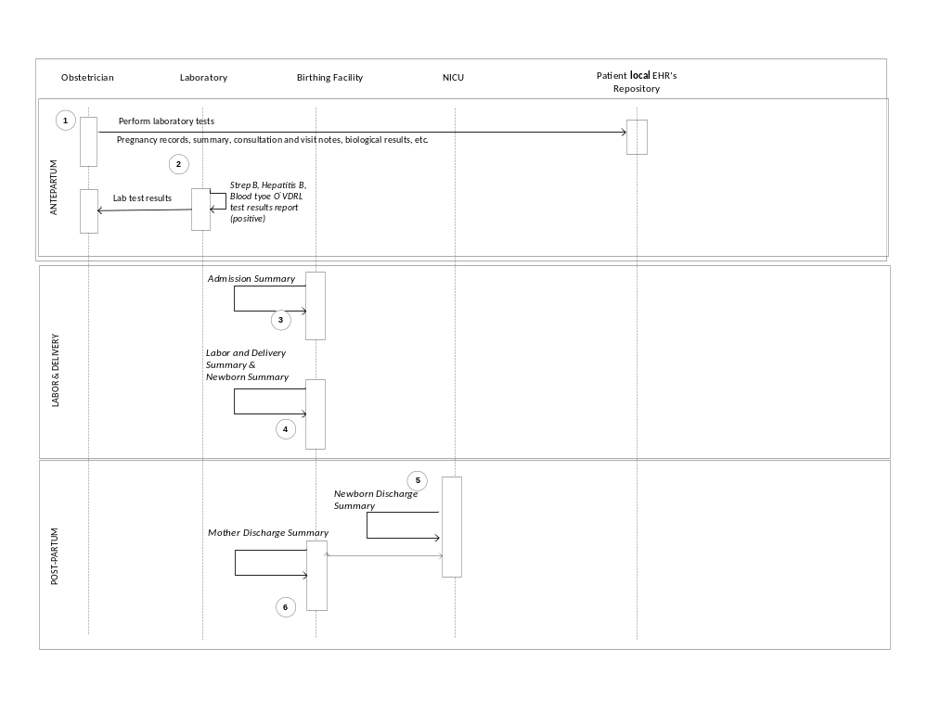

Figure X.2-1. Basic Process Flow in LDR Profile - Current Situation

X.3.3.2 Desired Situation
A multiparouspregnant woman has had prenatal care by her obstetrician who has an EHR that participates with the local health network, and all documents related to the patient’s pregnancy are accessible due to the implementation of various clinically interoperable profiles based on national specifications who are in turn based on IHE profiles.

While asymptomatic, the women had a Group B Streptococcus test performed just recently, with a positive result returned on Friday afternoon by the laboratory (2), but the patient has not yet been notified of the result. She is also blood type O negative and her hepatitis B status and VDRL were reported as "positive".

On Saturday, she has a rapid onset of labor at 35 weeks gestation, rushing to the local birthing center with just enough time to enter the Labor and Delivery suite before spontaneously delivering an infant with an APGAR score of 5 at 1 minute, and a score of 8 at 5 minutes. The mother is unaware of the positive Group B Streptococcus result, or the just returned hepatitis B positive and VDRL positive results. Likewise, the covering obstetrician is unaware of the positive Streptococcus B, Hepatitis B and VDRL results, and does not notify the pediatrician or nursery staff. Thus this information is not captured in the Admission Assessment Labor and Delivery Summary initially (3, 4).

Due to the early gestation and the and unavailability of Special Care Nursery services at the birthing center, the infant is transported to the nearest NICU five miles away.

The NICU care providers at the receiving facility review the mother’s Antepartum record, realize she is at high risk for Group B Strep sepsis and have obtained a sepsis evaluation which was positive hence appropriate antibiotic treatment preventing full blown sepsis. They also realize that the baby may have been exposed to both hepatitis B and syphylis, and initiate the potentially life-saving prophylaxis, evaluation and treatment. Because the mother is Rh negative, they also determine the baby's blood type and order an early bilirubin level.

When the mother's obstetrician calls the NICU the next morning, she is extremely happy to hear that evaluation and treatment are already underway at the NICU. The obstetrician can then begin further infectious disease testing and treatment of the mother, who is her patient, and will have access to the baby's diagnostic work-up in the NICU hospital's EHR to further focus and clarify the mother's treatment.

Since both the hepatitis B positive status and the VDRL positive status need to be reported to the local Health Department, that can be accomplished in a timely manner and further public health follow-up can be initiated once confirmatory studies have been performed.

The mother and the new born are discharged and a maternal discharge summary along with the information is created (6).

Note: the numbers in parenthesis need to be updated so that they correspond with the numbers in the activity diagram.

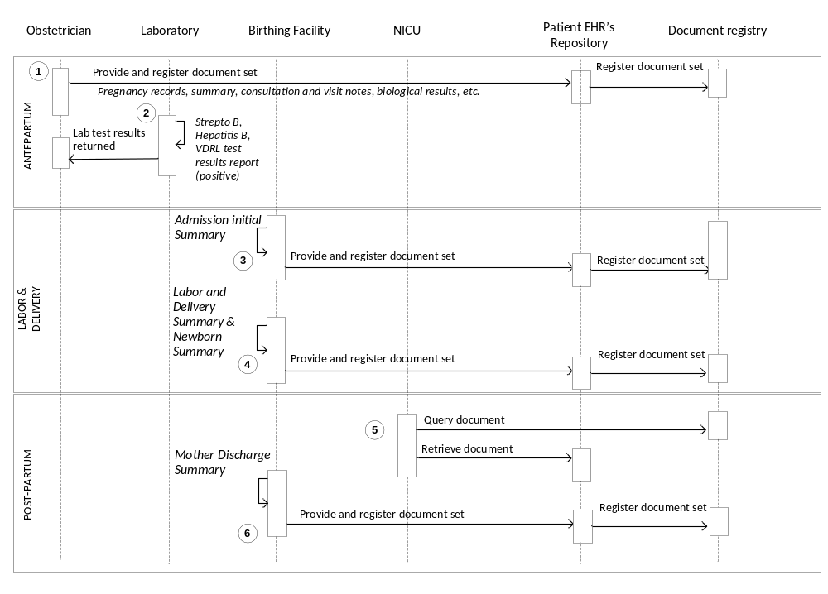

Figure X.2-1. Basic Process Flow in LDR Profile - Desired Situation

X.3 Grouping

X.3.1 Content Bindings with XDS, XDM and XDR
It is expected that the transfers of care will occur in an environment where the physician offices and hospitals have a coordinated infrastructure that serves the information sharing needs of this community of care. Several mechanisms are supported by IHE profiles:
- A registry/repository-based infrastructure is defined by the IHE Cross Enterprise Document Sharing (XDS) and other IHE Integration Profiles such as patient identification (PIX & PDQ) and notification of availability of documents (NAV).
- A media-based infrastructure is defined by the IHE Cross Enterprise Document Media Interchange (XDM) profile.
- A reliable messaging-based infrastructure is defined by the IHE Cross Enterprise Document Reliable Interchange (XDR) profile.
- All of these infrastructures support Security and privacy through the use of the Consistent Time (CT) and Audit Trail and Node Authentication (ATNA) profiles.
For more details on these profiles, see the IHE IT Infrastructure Technical Framework. Content profiles may impose additional requirements on the transactions used when grouped with actors from other IHE Profiles.

X.3.2 Cross Enterprise Document Sharing, Media Interchange and Reliable Messages
Actors from the ITI XDS, XDM and XDR profiles embody the Content Creator and Content Consumer sharing function of this profile. A Content Creator or Content Consumer must be grouped with appropriate actors from the XDS, XDM or XDR profiles, and the metadata sent in the document sharing or interchange messages has specific relationships to the content of the clinical document described in the content profile.

X.3.3 Notification of Document Availability (NAV)
A Document Source should provide the capability to issue a Send Notification Transaction per the ITI Notification of Document Availability (NAV) Integration Profile in order to notify one or more Document Consumer(s) of the availability of one or more documents for retrieval. One of the Acknowledgement Request options may be used to request from a Document Consumer that an acknowledgement should be returned when it has received and processed the notification. A Document Consumer should provide the capability to receive a Receive Notification Transaction per the NAV Integration Profile in order to be notified by Document Sources of the availability of one or more documents for retrieval. The Send Acknowledgement option may be used to issue a Send Acknowledgement to a Document Source that the notification was received and processed.

X.3.4 Document Digital Signature (DSG)
When a Content Creator Actor needs to digitally sign a document in a submission set, it may support the Digital Signature (DSG) Content Profile as a Document Source. When a Content Consumer Actor needs to verify a Digital Signature, it may retrieve the digital signature document and may perform the verification against the signed document content.

X.4 LDR Security Considerations
LDR is a content profile, and as such it is expected that the transfers of PHI will occur in an environment where the physician offices and hospitals have a coordinated infrastructure that serves the information sharing needs of this community of care. The appropriate risk assessment for that infrastructure must guide the security considerations when implementing the LDR profile. When an LDR Content Creator and Content Consumer are grouped with actors from IHE integration profiles (e.g. XDS, XDR), then the Security Considerations for the integration profiles will be used when
implementing the LDR profile.
X.4.1 LDR Specific Risk Considerations
In addition to the usual considerations when sharing PHI, the LDR profile introduces a unique situation since the record is about two patients – the mother and the new born child. This introduces a risk for data integrity of the mother’s and child’s record. The mitigation for this risk is archived by a properly conifgured system which handles the documentation of the delivery process and unambiguously allows the recording of the appropriate data for the mother and child.

More consideration will be given in Volume 2, security section, based on the Whitepaper Security Cookbook.

<Appendix A> Actor Summary Definitions
Content Creator - The Content Creator Actor is responsible for the creation of content and transmission to a Content Consumer.
Content Consumer – The Content Consumer Actor is responsible for viewing, import, or other processing of content created by a Content Creator Actor.

<Appendix B> Transaction Summary Definitions
Transactions are interactions between actors that transfer the required information through standards-based messages.

Volume 2 - Transactions

Add section 3.Y

3.Y <Transaction Name>
This section corresponds to Transaction Y of the IHE Technical Framework. Transaction Y is used by the <ABC> and <DEF> actors.

3.Y.1 Scope

3.Y.2 Use Case Roles
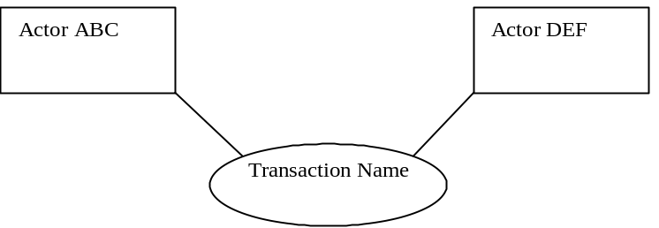

Actor:

Role:

Actor:

Role:

Actor:

Role: .

3.Y.3 Referenced Standard
<e.g., HL7 2.3.1 Chapters 2, 3>
<e.g. DICOM 2008 PS 3.3: A.35.8 X-Ray Radiation Dose SR IOD>

3.Y.4 Interaction Diagram
<the interaction diagram shows the detailed standards-based message exchange that makes up the IHE transaction>
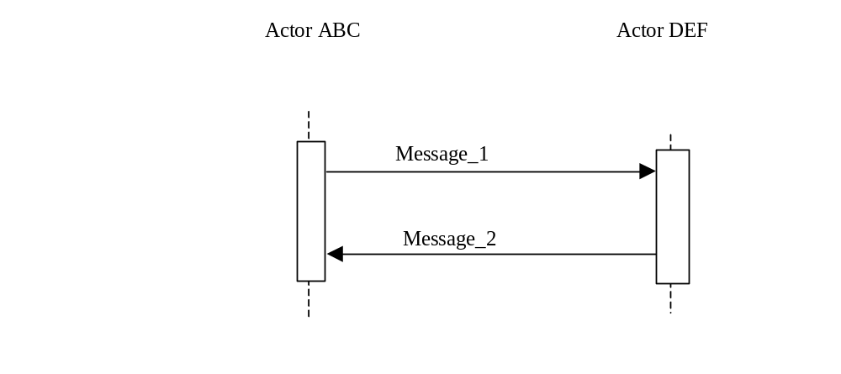

3.Y.4.1 <Message_1 Name>
<One or two sentence description of the first message of the above interaction diagram, typically relating the message to the relevant standard>

3.Y.4.1.1 Trigger Events
<description of the real world events that cause the initiation of the first message>

3.Y.4.1.2 Message Semantics
<detailed description of the meaning, structure and contents of the first message including any IHE specific clarifications of the message format, attributes, etc.>

3.Y.4.1.3 Expected Actions
<description of the actions expected to be taken as a result of sending or receiving this message>

3.Y.4.2 <Message_2 Name>
<One or two sentence description of the the next message in the above interaction diagram, typically relating the message to the relevant standard. Note, repeat this section as necessary based on the number of messages in the interaction diagram>

3.Y.4.2.1 Trigger Events
<description of the real world events that cause the initiation of the next message>

3.Y.4.2.2 Message Semantics
<detailed description of the meaning, structure and contents of the next message including any IHE specific clarifications of the message format, attributes, etc.>

3.Y.4.2.3 Expected Actions
<description of the actions expected to be taken as a result of sending or receiving this message>

3.Y.5 Security Considerations
<description of the transaction specific security consideration. Such as use of security profiles. >

3.Y.5.1 Security Audit Considerations
<This section should specifiy any specific ATNA security audit event that is associated with this transaction and requirements on the encoding of that audit event. >

3.Y.5.1.(z) Actor Specific Security Considerations
<This section should specifiy any specific security considerations on an Actor by Actor basis.>

<Appendix letter> Appendix_Name
Appendix A: The Relationship between the various types of PCC History and Physical Architecture

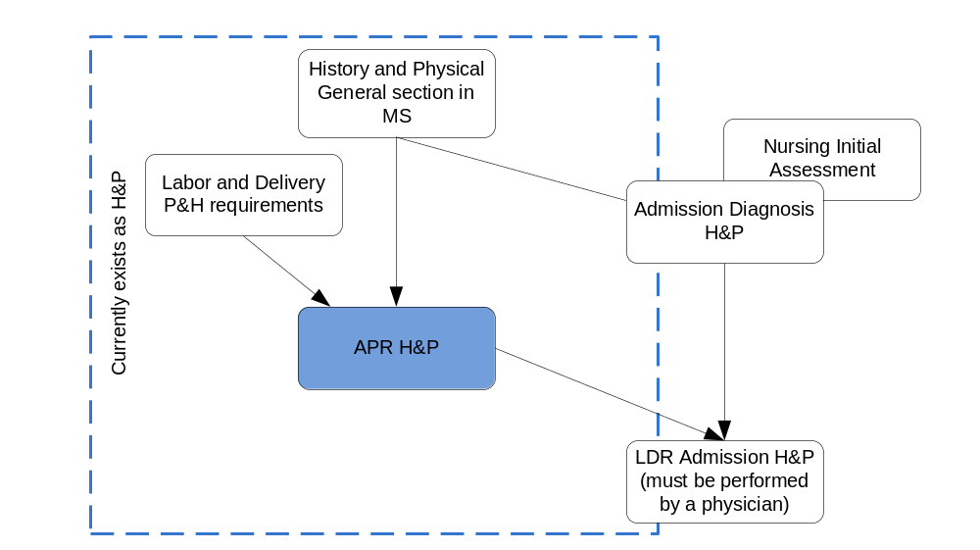

The History and Physical section present in an Admission Diagnosis Assessment contains more information then a general History and Physical Section. The Physical and History section present in a LDR Admission Assessment contains more information then the History and Physical section present in Admission Diagnosis Assessment. This can be seen in the above diagram.

There is also a Nursing Initial Assessment, but a physician has to do a History and Physical Admission Assessement for the Labor and Delivery as per the Joint Commission recommendations. These documents are all part of the History and Physical in general. A consensus must be established as to what documents will be part of the LDR record.

,2 Normally this is a separate document which is part of the Antepartum Record. This document might be re-created if the patient data was not captured in the system (If the EHR does not contain the APR or it is not part of the appropriate health information exchange network in order to obtain the Antepartum Summary, pertinent questions will be asked. If the document is present in paper form, it might be scanned and integrated in the mother’s record. It is normal that there will be a certain amount of overlap between the APR and LDR

